Epidemic Outbreak prediction map of Dengue and COVID_19 in India

1. Dengue Epidemic Outbreak prediction
2. Factors affected to Dengue

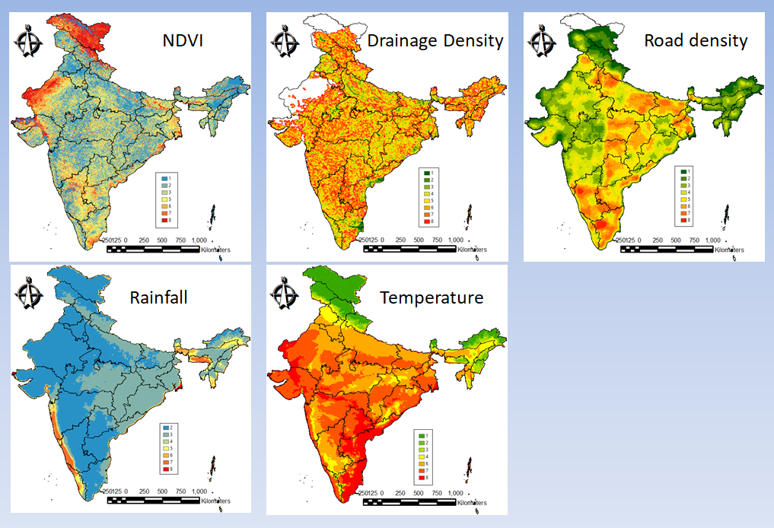

Fig.1. Factors affected to Dengue

I have selected 5 factors influenced to Dengue like NDVI, drainage density, road density, rainfall and temperature. These factors are reclassified into 9 classes that is high in favorite to Dengue disease.

1. Dengue Epidemic Outbreak prediction by weighted overlay

In order to mapping for Dengue Epidemic Outbreak prediction, weighted overlay is applied to 5 factors, where the weights of each factor is calculated by AHP method from pairwise comparison between each factor.

Table 1. Pairwise comparison between each factor and weights of factors

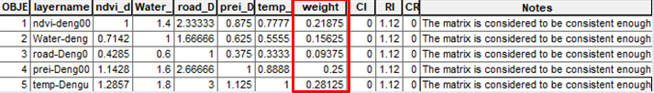

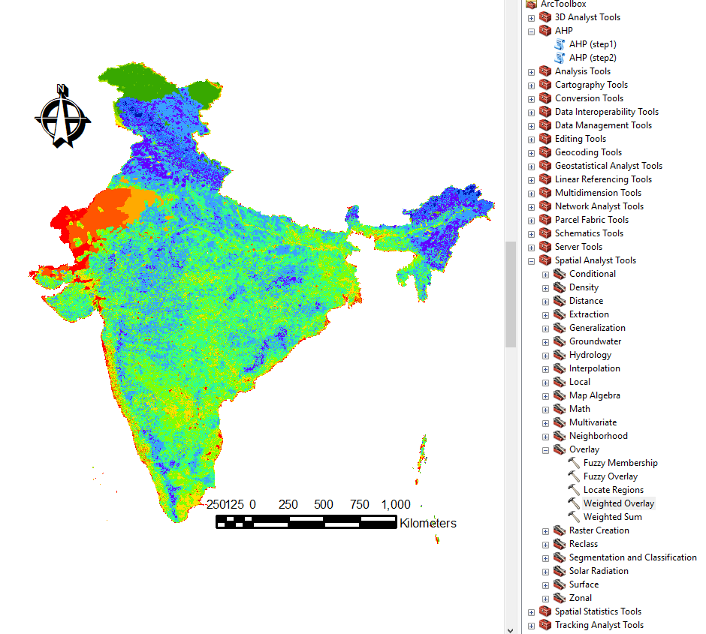

Fig. 2. Dengue Epidemic Outbreak prediction map and AHP and weighed overlay modules

The Dengue Epidemic Outbreak prediction map is completed by overlaying with weights from AHP(table1). The calculation modules are used in ArcGIS 10.5.

1. Dengue Epidemic Outbreak prediction map

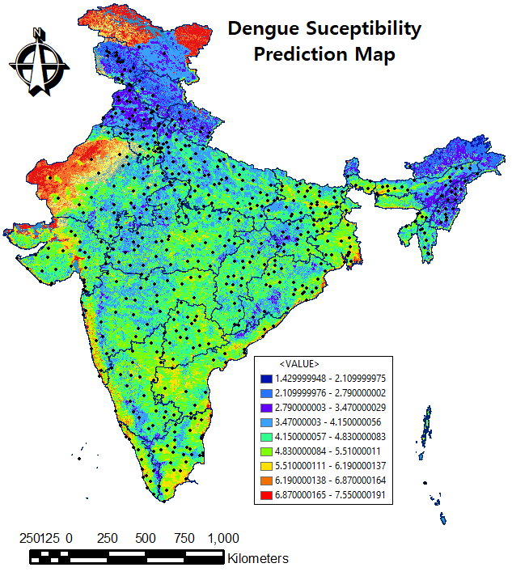

Fig. 3. Dengue Epidemic Outbreak prediction map and rainfall & temperature inventory points

In Fig.3, the high value indicates that the Dengue susceptibility is high. The marked points (543) show observation locations of temperature and rainfall in August 29th,2023.

Fig.4. The relationship between temperature and Dengue grade

In Fig 4, we can see that the more temperature is higher Dengue disease risk up to 35 degree centigrade.

Fig.5. The relationship between humidity and Dengue grade

In Fig. 5, we can see that the higher grade of Dengue is between 40-80% in humidity.

1. COVID-19 Epidemic Outbreak prediction
2. Factors affected to COVID-19

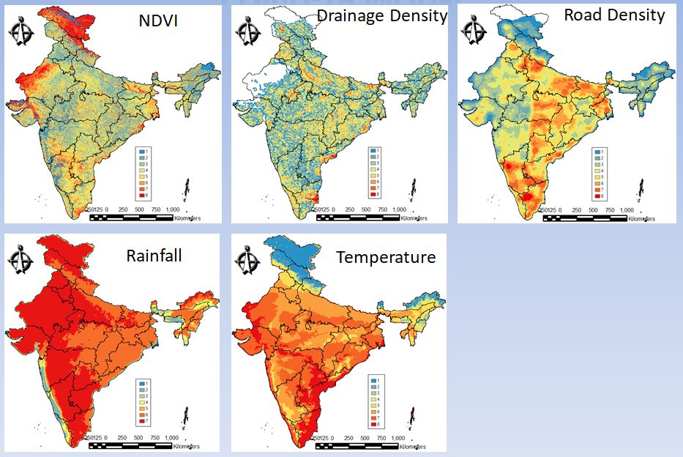

Fig.6. Factors affected to COVID-19

I have selected 5 factors influenced to COVID-19 like NDVI, drainage density, road density, rainfall and temperature. These factors are reclassified into 9 classes that is high in favorite to COVID-19 disease, but somewhat different with Dengue in some factors like temperature and rainfall because of different susceptibility to each disease.

1. COVID-19 Epidemic Outbreak prediction by weighted overlay

In order to mapping for COVID-19 Epidemic Outbreak prediction, weighted overlay is applied to 5 factors, where the weights of each factor is calculated by AHP method from pairwise comparison between each factor.

Table 2. Pairwise comparison between each factor and weights of factors

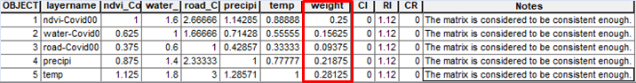

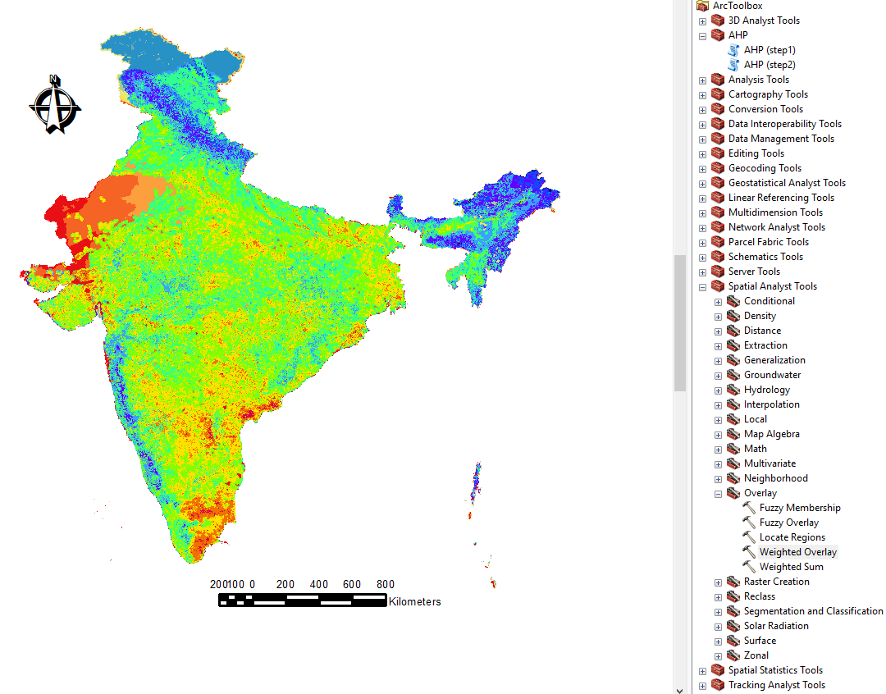

Fig.7. COVID-19 Epidemic Outbreak prediction map and AHP and weighed overlay modules

The COVID-19 Epidemic Outbreak prediction map is completed by overlaying with weights from AHP(table2). The calculation modules are used in ArcGIS 10.5.

1. COVID-19 Epidemic Outbreak prediction map

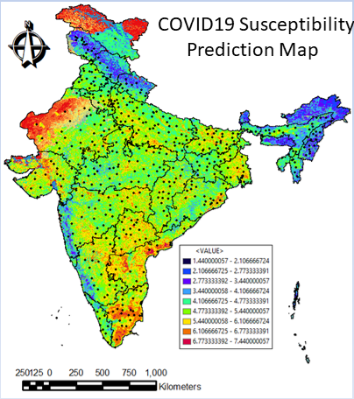

Fig. 8. COVID-19 Epidemic Outbreak prediction map and rainfall & temperature inventory points

In Fig.8, the high value indicates that the COVID-19 susceptibility is high. The marked points(543) show observation locations of temperature and rainfall in August 29th,2023.

Fig.9. The relationship between temperature and COVID-19 grade

In Fig. 9, we can see that the more temperature is higher COVID-19 disease risk up to 35 degree centigrade.

Fig.10. The relationship between humidity and COVID-19 grade

In Fig. 10, we can see that the higher grade of COVID-19 is between 40-80% in humidity.

1. Conclusion

Firstly, the spatial features of Dengue and COVID-19 are similar(Fig.11,Fig.12), although the origins are different.

Secondly, the relationship of the risk grade with temperature and humidity is very similar between Dengue and COVID-19(Fig.4, 5, 9, 10).

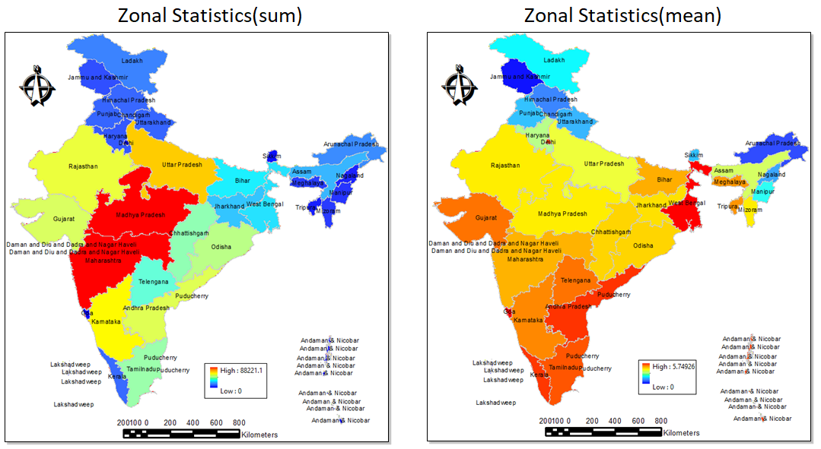

Fig.11. Zonal statistics of Dengue Epidemic Outbreak

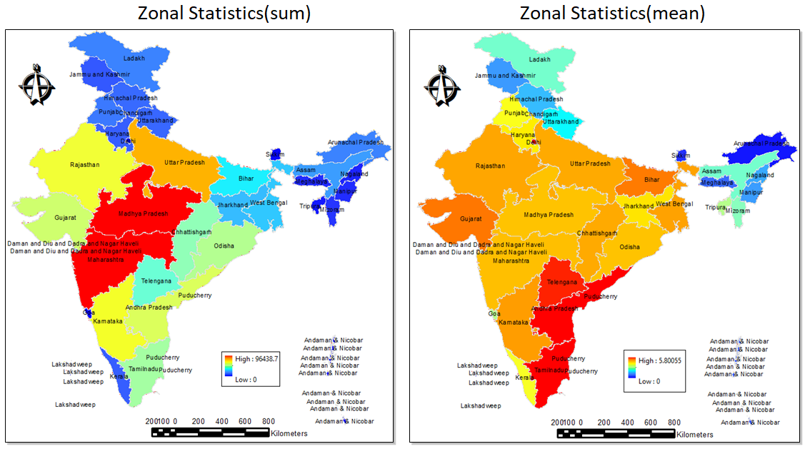

Fig.12. Zonal statistics of COVID-19 Epidemic Outbreak

1. Reference
2. Anh-huy Hoang et al.,Identifying Spatio-Temporal Clustering of the COVID-19 Patterns Using Spatial Statistics: Case Studies of Four Waves in Vietnam, International Journal of Applied Geospatial Research,2022, Volume 13 , Issue 1.
3. Yingtong Ye , Environmental influencing factors of COVID-19 based on geographic information system techniques: A literature review, Proceedings of the 2023 International Conference on Environmental Geoscience and Earth Ecology.
4. Amanda K.Weaver et al., Environmental Factors Influencing COVID-19 Incidence and Severity, Annu.Rev.Public Health 2022. 43:271–91.